How to Update Your Committee Roster

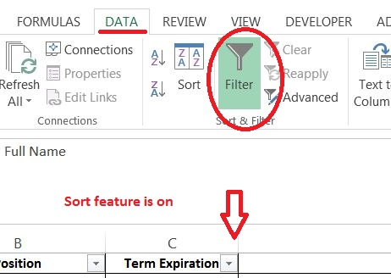
1. Follow the directions for downloading your current committee roster from the ASABE website, Excel format is recommended. (separate document). Do not rely on your previous roster from a year ago as this can change during the year.
2. Set up your roster for a data sort

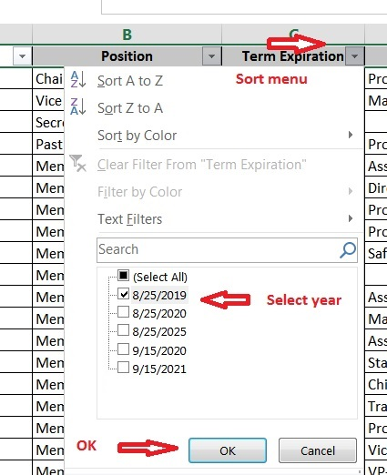
3. Sort for expiring members Highlight expiring members
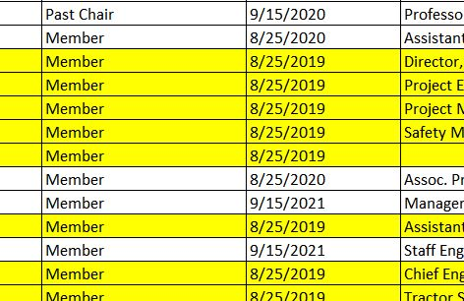

4. Contact expiring member IN ADVACE OF THE MEETING via a quick email. See separate directions for roster renewal email below. Send your updates to staff before AIM if possible.
5. Finalize your renewals, added or deleted members, new officers, representatives and liaisons during your meeting.
6. Report CLEARLY to ASABE staff the changes with the members listed alphabetically by last name.
Use color, added wording, etc. for identification. This will save staff time when updating.
Please include all newly elected officers and representatives and liaisons for each group identified by your committee and their term expiration.
Bylaws are in place to answer your individual committee questions and should be found on your committee forum library. If you cannot find your Bylaws, contact ASABE staff for assistance.
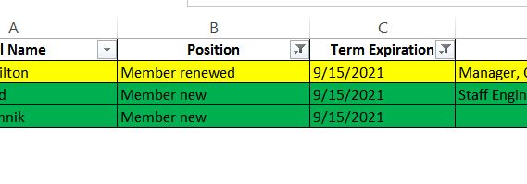

7. Let ASABE staff know if you need assistance contacting members. We are happy to help out.

Member Renewal Information E-mail Instructions
- You can either send individual emails to your expiring members if you only have a few or you can use the Microsoft Word Mail Merge feature detailed below. Link for directions on downloading your roster.
- Sample email:
NAME,
Your membership on XXX committee is expiring this year. Please reply to me your wishes from the selection below.
I wish to renew my membership on the committee for 3 years
I wish to allow my membership to expire
I wish to renew and change my status to (from Observing to Voting or Voting to Observing)
If I do not hear from you by July 31, your name will be removed from the committee roster.
Thank you for your quick response,
Signature

2. A quick mail merge email to expiring members allows for a five second response from them and makes your job of updating your committee roster that much easier.
1. Download your committee roster (See instructions below)
2. Sort and delete all but the expiring members, be sure each column is labeled with labels in row 1. (See instructions below)
3. Save to your computer
4. Open Microsoft Word and your draft letter
a. Select “Mailings” from the ribbon menu
b. “Start Mail Merge”, select E-mail messages from the drop-down menu
c. “Select recipients”, “Use existing list”. Browse to your saved list of expiring members and select.
d. In your letter, highlight the Name and select “Insert Merge Field”, locate Name and select it. Include the number and name of your committee in the email. Repeat “Insert Merge Field” with the committee position.
e. From ribbon menu select “Preview Results”. If you are happy with the merge, go to finish. If you wish to change something, go back and make your changes. Always check with preview through at least 6 messages.
f. Under “Finish & Merge”. “Send E-mail Message”.
g. The message box will allow for you to write a Subject for the email. ASABE MS-23/6 Committee renewal, immediate quick reply requested.
you options for download.

