**ISO #####-#:####(X)**

ISO TC ###/SC ##/WG #

Secretariat: XXXX

**Title** (Introductory element — Main element — Part #: Part title)

WD/CD/DIS/FDIS stage

**Warning for WDs and CDs**

This document is not an ISO International Standard. It is distributed for review and comment. It is subject to change without notice and may not be referred to as an International Standard.

Recipients of this draft are invited to submit, with their comments, notification of any relevant patent rights of which they are aware and to provide supporting documentation.

[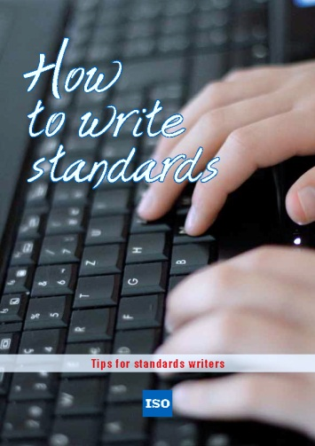](http://www.iso.org/iso/how-to-write-standards.pdf) To help you, this guide on writing standards was produced by the ISO/TMB and is available at <http://www.iso.org/iso/how-to-write-standards.pdf>

© ISO 2013

All rights reserved. Unless otherwise specified, no part of this publication may be reproduced or utilized otherwise in any form or by any means, electronic or mechanical, including photocopying, or posting on the internet or an intranet, without prior written permission. Permission can be requested from either ISO at the address below or ISO's member body in the country of the requester.

ISO copyright office

Case postale 56 • CH-1211 Geneva 20

Tel.  + 41 22 749 01 11

Fax  + 41 22 749 09 47

E-mail  copyright@iso.org

Web  www.iso.org

Published in Switzerland.

**Contents**

This template allows you to work with default MS Word functions and styles. You can use these if you want to maintain the Table Of Contents automatically and apply auto-numbering if this is your preference. Delete this Table of Contents if not required.

Foreword 3

Introduction 3

1 Scope 4

2 Normative references 4

3 Terms and definitions 4

4 Clause title 4

5 Clause title 4

6 Clause title 4

Annex A (informative) Annex title e.g. Example of a figure and a table 5

A.1 Clause 5

Bibliography 6

# Foreword

ISO (the International Organization for Standardization) is a worldwide federation of national standards bodies (ISO member bodies). The work of preparing International Standards is normally carried out through ISO technical committees. Each member body interested in a subject for which a technical committee has been established has the right to be represented on that committee. International organizations, governmental and non-governmental, in liaison with ISO, also take part in the work. ISO collaborates closely with the International Electrotechnical Commission (IEC) on all matters of electrotechnical standardization.

The procedures used to develop this document and those intended for its further maintenance are described in the ISO/IEC Directives, Part 1. In particular the different approval criteria needed for the different types of ISO documents should be noted. This document was drafted in accordance with the editorial rules of the ISO/IEC Directives, Part 2. [www.iso.org/directives](http://www.iso.org/directives)

Attention is drawn to the possibility that some of the elements of this document may be the subject of patent rights. ISO shall not be held responsible for identifying any or all such patent rights. Details of any patent rights identified during the development of the document will be in the Introduction and/or on the ISO list of patent declarations received. [www.iso.org/patents](http://www.iso.org/patents)

Any trade name used in this document is information given for the convenience of users and does not constitute an endorsement.

The committee responsible for this document is ISO/XXX.

ADD INFORMATION ABOUT REPLACED STANDARDS AND OTHER PARTS AS NECESSARY

# Introduction

A paragraph or more.

**Title** (Introductory element — Main element — Part #: Part title)

# 1 Scope

A paragraph.

# 2 Normative references

The following documents, in whole or in part, are normatively referenced in this document and are indispensable for its application. For dated references, only the edition cited applies. For undated references, the latest edition of the referenced document (including any amendments) applies.

ISO #####‑#:20##, *General title — Part #: Title of part*

# 3 Terms and definitions

**3.1**

**term**

text of the definition

Note 1 to entry: Text of the note.

**3.2**

**term**

text of the definition

# 4 Clause title

Type text here - use subclauses if required e.g. 4.1 or 4.1.1. For example:

**4.1 Subclause**

# 5 Clause title

Type text here - use subclauses if required e.g 5.1 or 5.1.1.

# 6 Clause title

Type text here - use subclauses if required e.g. 6.1 or 6.1.1.

# Annex A (informative) Annex title e.g. Example of a figure and a table

# A.1 Clause

Type text here - use subclauses if required e.g A.1.1 or A.1.1.1.

Dimensions in millimetres

Fig B1

**Key**

|  |  |  |  |
| --- | --- | --- | --- |
| 1 | control panels | 6 | machine |
| 2 | machinery space | 7 | AC and/or DC power ports |
| 3 | system boundary | 8 | main switch |
| 4 | machinery space | 9 | output power port |
| 5 | main control/control cabinet |  |  |
| a | Figure footnote. | | |
| b | Second figure footnote. | | |

NOTE   Figure note.

**Figure A.1 — Example**

**Table A.1 — Example**

|  |  |  |  |  |
| --- | --- | --- | --- | --- |
| **Type** a | **No. serie** | **Pressure** | **Length** | **Temperature** |
| *p*1 | *l*2 | *T*1 |
| MPa | mm | °C |
| A | 248-i | 50 | 216 | 50 |
| B | 556-i | 100 b | 287 | 60,5 |
| C | 43-ii | 200 | 300 | 38 |
| NOTE   Table note.  a   Table footnote.  b   Second table footnote. | | | | |

# Bibliography

[1] ISO #####‑##:20##, *General title — Part ##: Title of part*